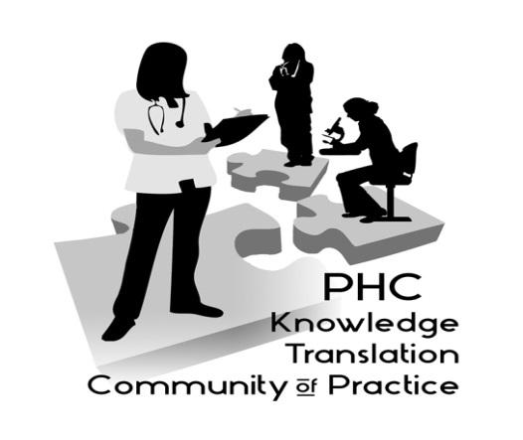

Notes from the Sept 11, 2018 meeting of the PHC Knowledge Translation (KT) Community of Practice

Jaki Thornhill, Professional Practice Lead for Clinical Nutrition at Providence
Health Care, led a session describing her KT project addressing malnutrition in hospitals. Jaki’s project was funded by the PHC/VCH KT Challenge program, and will implement the Integrated Nutrition Pathway for Acute Care (INPAC) at St Paul’s Hospital to improve clinical outcomes for patients.

For the recording of the session:

Streaming recording link:
https://bcsupportunit.webex.com/bcsupportunit/ldr.php?RCID=87d64f1b43301991cbe947bdece21104
Download recording link:
https://bcsupportunit.webex.com/bcsupportunit/lsr.php?RCID=4b9245d1731099386947aaa272526c17

If you’d like to share a project to elicit ideas from the group or if you have any questions, please contact us: Aggie Black, Director, Research and Knowledge Translation, Professional Practice (ablack@providencehealth.bc.ca) or Emily Zamora, Clinical Resource Dietitian at PHC (ezamora1@providencehealth.bc.ca).

More Information: http://www.providenceresearch.ca/providence-health-care-knowledge-translation-community-practice

Next session: March 12, 2019, Sarah Munro: http://www.cheos.ubc.ca/people/sarah-munro/

This session was held in partnership with the BC SUPPORT Unit.

